**D.4.1) Test Procedure for Communication Subsystem**

In tests of communication subsystem, Revolusys demonstrated the communication system that utilizes the on-off modulation at 19200 baud with UART pins of the microcontrollers.

The test data stream was upload to input as input and output of the system for transmitter led to receiver photodiode distances from 5 cm to 15 cm (with 1 cm steps) and additionaly 20 cm 30cm and 45 cm for different light conditions (dark, lab light) was observed. This process was repeated 25 times for each data point and the average error was taken into account.

In these, to illustrate the proper operation of the commination system, 1024 bit message signal was transmitted. The number of message bit was selected arbitrarily, the communication system will transmit more than 1024 bits at once on its operation. The transmitted stream utilizes UART chip of the microcontroller and therefore, its start and stop bits are already defined for each data frame.

The received data (with serial read command of Arduino), was read on the COM screen of Arduino and compared with the message signal in MATLAB. The number of error in the received 1024 bit message signal was determined and recorded for different trials.

The setup for lab light condition test is seen in Figure **KQQ**. The setup for dark condition test is seen in Figure **QWE** and Figure **QQQ**. In this test, a dark environment was reached via using wooden pieces seen in Figure **QWE**. The light level at this test condition is seen in Figure **QQQ.** “1” in these figures shows the LED while “2” shows the photodiode.

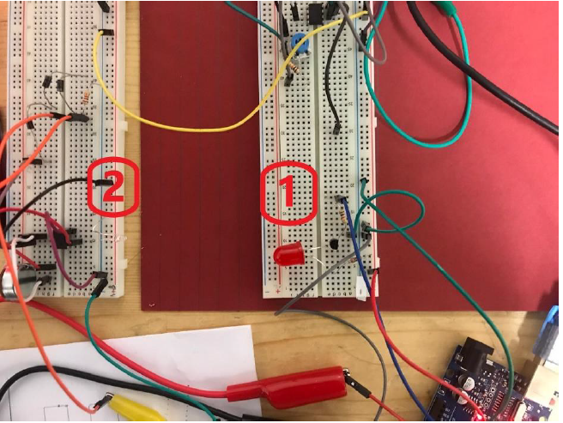

*Figure* ***KQQ:*** *The test setup for lab light condition*

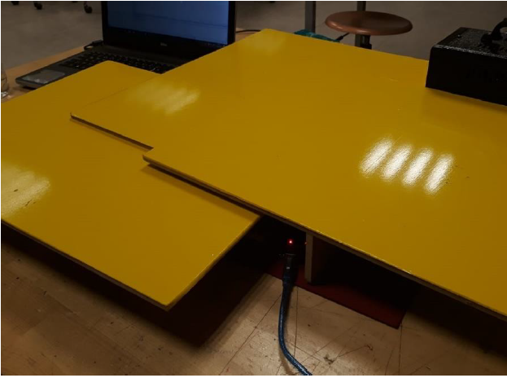

*Figure* ***QWE:*** *The test setup for dark light condition*

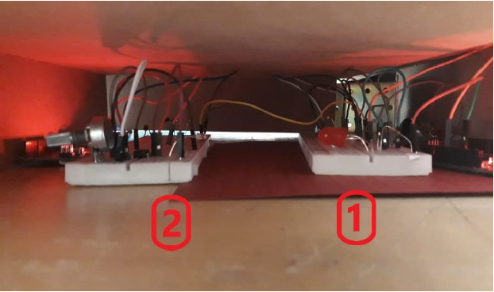

*Figure* ***QQQ:*** *The test setup for dark light condition*